Ex. No: 3a) Shell Script – Reverse of Digit
NAME : ENIYA B A
CLASS : CSE – A
ROLL NO : 230701085
Program :
echo "Enter the digit:"
read n
rev=0
while [ $n -gt 0 ]
do
d=`expr $n % 10`
rev=`expr $rev \* 10 + $d`
n=`expr $n / 10`
done
echo "The reversed number is $rev"

OUTPUT :

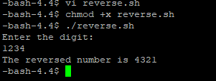

Ex. No.: 3b) Shell Script – Fibbonacci Series
Program :
echo &quot;Enter the number:&quot;
read n
a=0
b=1
echo &quot;fibonacci series&quot;
echo &quot;$a&quot;
echo &quot;$b&quot;
for (( i=3; i&lt;=n; i++ ))
do
c=`expr $a + $b`
echo &quot;$c&quot;
a=$b
b=$c
done

OUTPUT :

